**Python + Power BI Portfolio Project Document**

**Title: Top Indian Companies Sales & Revenue Analysis Dashboard**

**Project Overview**

This project focuses on analyzing the sales and revenue data of top Indian companies using Python and Power BI. The goal is to provide a comprehensive dashboard that visualizes key metrics and trends, enabling better business decision-making. The project includes data import, cleaning, and preparation, followed by visualization creation using Python libraries and Power BI.

**Development Steps**

1. **Import Data into Power BI:**
   * The initial step involved importing the dataset containing sales and revenue information of top Indian companies into Power BI.
2. **Data Cleaning and Preparation:**
   * The data was cleaned and pre-processed to ensure accuracy and consistency. This included handling missing values, correcting data types, and removing duplicates where necessary.

**Visualization Creation Using Python and Power BI**

1. **Bar Chart for Company Name by Revenue:**
   * **Objective:** Display companies in descending order of revenue.
   * **Tools & Libraries:** Python (pandas, matplotlib), season.
   * **Details:** A bar chart was created using matplotlib to rank companies by revenue, providing a clear visual of the top performers.
2. **Stacked Bar Chart for Top 10 Company Names by Revenue & Profit:**
   * **Objective:** Visualize the top 10 companies by revenue and their corresponding profits.
   * **Tools & Libraries:** Python (matplotlib), season.
   * **Details:** A stacked bar chart was generated to display both revenue and profit figures, enabling a comparative analysis of the top 10 companies.
3. **Scatter Plot for Revenue vs. Profit:**
   * **Objective:** Examine the relationship between revenue and profit.
   * **Tools & Libraries:** Python (matplotlib), season.
   * **Details:** A scatter plot was used to visualize the correlation between revenue and profit, helping to identify trends and outliers.
4. **Pie Chart for Industry Distribution:**
   * **Objective:** Show the distribution of companies across different industries.
   * **Tools & Libraries:** Python (matplotlib), season.
   * **Details:** A pie chart was created to represent the proportion of companies in each industry, providing insights into the dominant sectors.
5. **Clustered Bar Chart for Companies of Average Revenues and Profits Across Industries:**
   * **Objective:** Compare average revenues and profits across different industries.
   * **Tools & Libraries:** Python (matplotlib), season.
   * **Details:** A clustered bar chart was used to highlight the differences in financial performance across industries.
6. **Scatter Plot for Profit vs. Revenue Growth Percentage:**
   * **Objective:** Analyze the relationship between profit and revenue growth percentage.
   * **Tools & Libraries:** Python (matplotlib), season.
   * **Details:** This scatter plot helped identify companies with significant revenue growth and how it correlates with their profit margins.

**Refer:** Python code Document.

**Interactive Dashboard Elements**

1. **Slicers:**
   * **Objective:** Allow users to filter and explore data based on specific criteria.
   * **Slicers Created For:**
     + Percentage of Revenue Growth
     + Industry Type
     + Company Name
   * **Details:** These slicers enhance the dashboard's interactivity, enabling users to drill down into specific data segments and gain deeper insights.

**Outcome Summary**

* **Top 10 Companies Analysis:**
  + The oil and gas industry stands out as the leading sector, generating the maximum revenue and profit compared to other industries. This highlights the sector's dominance and significance in the Indian market.
* **Industry Distribution:**
  + The average distribution of companies across various industries is approximately 6.7%. This metric provides an understanding of market diversity and concentration in different sectors.
* **Revenue Growth % vs. Profit:**
  + Most data points fall within the range of 0.3% to 25,000 in profit, indicating a standard growth pattern among the companies analyzed. Only a few outliers exceed this range, suggesting exceptional performance or specific circumstances.

**Recommendations and Insights**

1. **Focus on High-Performing Sectors:**
   * Companies should consider investing in or partnering with firms in high-performing sectors like oil and gas, as these sectors show strong financial metrics.
2. **Growth Strategies for Underperforming Industries:**
   * For industries with lower average revenues and profits, strategies such as innovation, cost reduction, and market expansion could be explored to enhance profitability.
3. **Monitoring Revenue Growth and Profit Trends:**
   * Continuous monitoring of revenue growth and profit trends is essential. Companies should identify factors driving growth or decline and adjust their strategies accordingly.

This document serves as a comprehensive overview of the "Top Indian Companies Sales & Revenue Analysis Dashboard," highlighting the project's objectives, development process, and key findings. The dashboard provides valuable insights that can guide strategic business decisions and enhance market competitiveness.

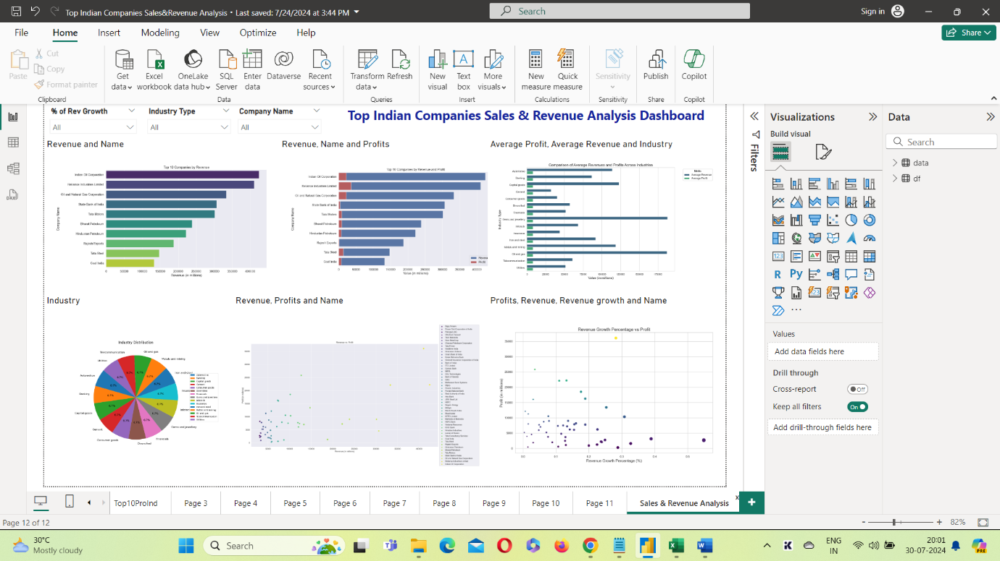

**Conclusion**

The "Top Indian Companies Sales & Revenue Analysis Dashboard" project successfully provided a comprehensive analysis of the sales and revenue data of leading Indian companies. By leveraging Python and Power BI, the project showcased various visualizations that highlighted key performance metrics and trends. The insights derived from these analyses are crucial for understanding market dynamics and guiding strategic decisions.

**Key Takeaways:**

1. **Industry Dominance:** The oil and gas sector emerged as a dominant industry, generating the highest revenue and profit. This indicates strong market positioning and potential growth opportunities within this sector.
2. **Market Diversity:** The industry distribution analysis revealed an average company distribution of approximately 6.7% across various industries, suggesting a relatively balanced market with opportunities for diversification.
3. **Growth and Profit Correlation:** The scatter plot analysis between profit and revenue growth percentage highlighted that most companies are within a standard growth range, with a few outliers demonstrating exceptional performance.
4. **Data-Driven Decision Making:** The interactive dashboard, equipped with various slicers and dynamic visualizations, enables stakeholders to explore data in detail. This feature allows for a more nuanced understanding of specific segments, aiding in data-driven decision-making.

**Recommendations:**

* **Investment Focus:** Companies should consider prioritizing investments in high-performing sectors such as oil and gas, while also exploring emerging opportunities in other industries.
* **Strategic Initiatives:** Underperforming industries may benefit from targeted strategies, such as innovation and market expansion, to enhance revenue and profit margins.
* **Continuous Monitoring:** Regular monitoring of financial metrics is essential to identify trends and make timely adjustments to strategies, ensuring sustained growth and profitability.

The successful completion of this project demonstrates the effectiveness of using advanced data analytics tools and techniques to derive actionable insights. The findings provide a solid foundation for further analysis and strategic planning, ultimately contributing to improved business outcomes and competitive advantage in the market.